The Reporting App

Second Harvest Food Bank

User Manual

# The Main Menu

The Main Menu is the first screen that you will see when you start The Pantry App. The top right side of the screen shows the current version number of the installation you are running. In the image below, we see it show that Version 1.0 is running. 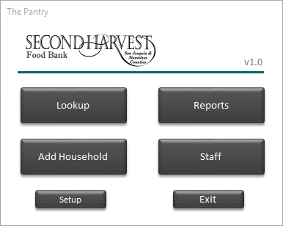

# Setup

If you have not completed the initial setup of The Pantry App, please refer to the *Initial Installation and Setup* document to go through that process.

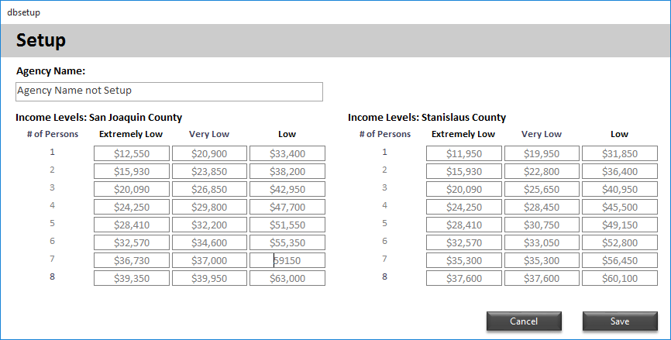

The Setup screen will allow you to update your Agency Name, which will show on the reports. This screen is also where you will update Income levels as define for each county. Start in one cell you can quickly update all values by hitting the [TAB] key to move through each field.

Hitting the [SAVE] button will update the values used on all reports created after the update.

# Staff

The Staff screen is used to maintain a list of people you want to be able to choose as an “Interviewer”. This comes up as an option while you are entering a new visit for a client.

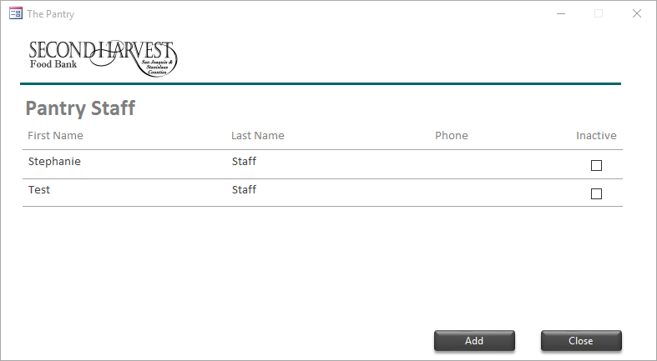

You can enter a First Name, Last Name, and Phone Number.

You can choose to make a staff member inactive using the checkbox to right. Setting a staff member to inactive will mean they no longer show up as a choice for the “Interviewer” option.

### Adding a Staff Member

Clicking the [Add] button will show you the Add Staff screen. On this screen you will enter a First Name, Last Name, and a Phone number.

### Editing a Staff Member

Clicking on a Staff Members name in the list will allow you to edit the current entry.

### Deleting a Staff Member

There is No option to delete a staff member. You would need to make them Inactive.

# Add Household

The Add Household button will allow you to add a new household address to the system.

1. Using the [Lookup] feature, ensure that the address is NOT already entered into the system. (using the [Lookup] feature is detailed later in this manual)
2. Click the [Add Household] button on the main menu.
3. The first screen will allow you to enter details about the household. Several fields are required.
   * Address, City, State, Zip Code *required
   * Home Phone
   * Annual Income (Total Income for entire household) *required
   * Verification Type (How was income verified)
   * Verification Date (the date income was verified)
   * Verified By (the staff member who verified income)
   * Income Type Checkboxes (choose which ones have been reported)
4. Click the [Next] button will save the household and automatically allow you to start entering Household Members.

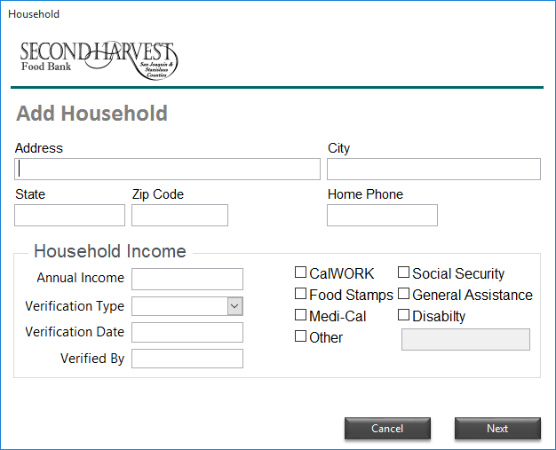

1. The Add Household Member screen allows you to enter specifics for one of the people living in the household. Several fields are required.
   * First Name, Last Name *required
   * Household role (options are Mother, Father, etc)
   * Gender (Choose Male or Female) *required
   * Marital Status (this is just informational)
   * Ethnicity *required
     1. Hispanic option (simply a checkbox to click if they reported Hispanic race)
     2. Observed option (checking this means client did not report it, but was observed by the interviewer to be Hispanic)
   * Birthdate *required
   * Status options
     1. Head of House (choose if they reported to be Head of the Household)
     2. Veteran
     3. Disabled
     4. Homeless (required homeless form to be completed by client)
   * Email
   * Mobile Phone, Alt Phone
   * Note (a place to put notes for each specific person)

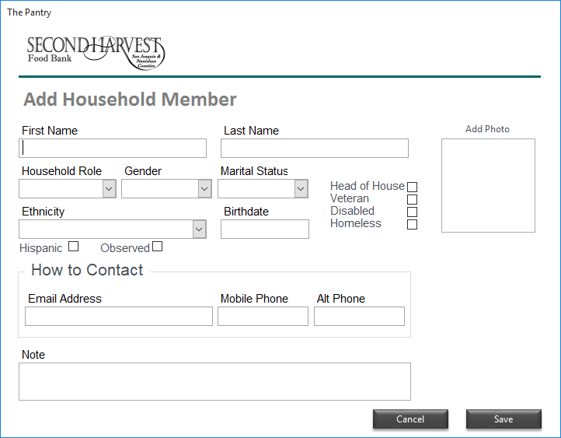

1. Click the [Save] button will save the person to the Household you created in the previous steps.
2. You will then be sent to the Household Details screen, which is detailed later in this manual.

# Lookup

The Lookup feature is where you will search through entries in The Pantry App. There are several options to search by and they are listed across the top of the screen.

1. Choose a Search item from the options on the top of the screen.
2. Enter text into the “Search Text” field will be what is looked for the search item you selected.
3. Clicking the [Search] button will update the results area with a list of the items found.
4. Double clicking on the result you want to see the details for will open the Household Details screen, which is detailed later in this manual.

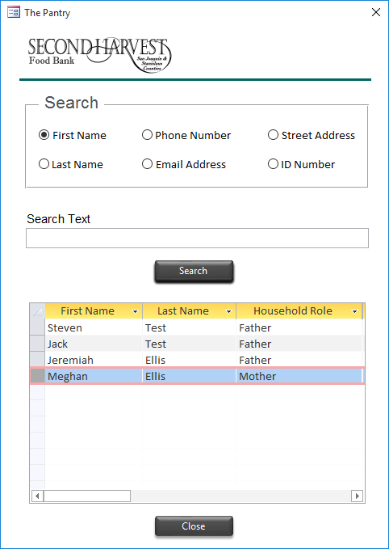

# Household Details

**2**

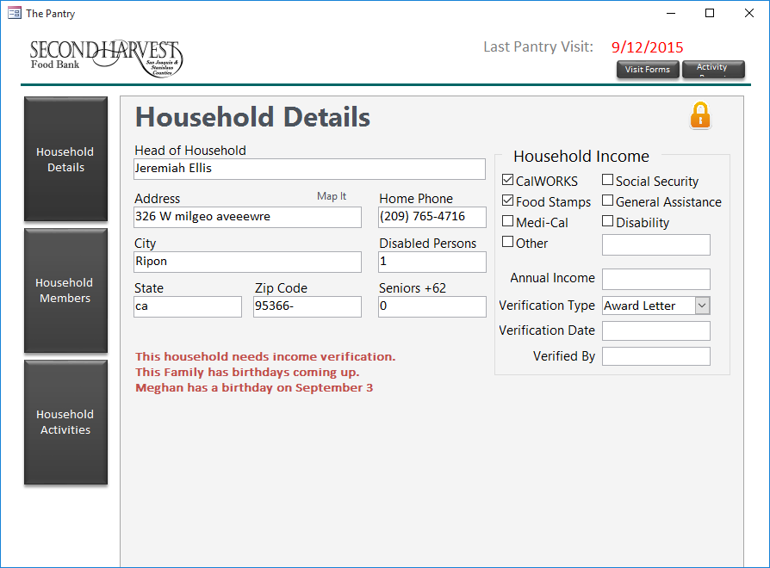

**5**

**4**

**3**

**1**

1. Navigation Buttons used to change between screens
2. Shows the households last activity date. Red text means they have visited in the current month already.
3. Print Household reports.
   1. Visit Forms: Used as intake for returning visitors instead of making them fill out a new form each time.
   2. Activity Report: Shows households Last 5 activities and Notes. Also has a large area to mark down notes for this new visit and the interviewer.
4. Lock Icon: when shown as locked, all fields on screen can not be altered. When shown as unlocked, fields on the screen can be edited. Any change made is saved to the database when the text cursor is move out of the text field.
5. This are display user notices. Hand for knowing about birthdays and income verification needs at a glance.

# Household Members

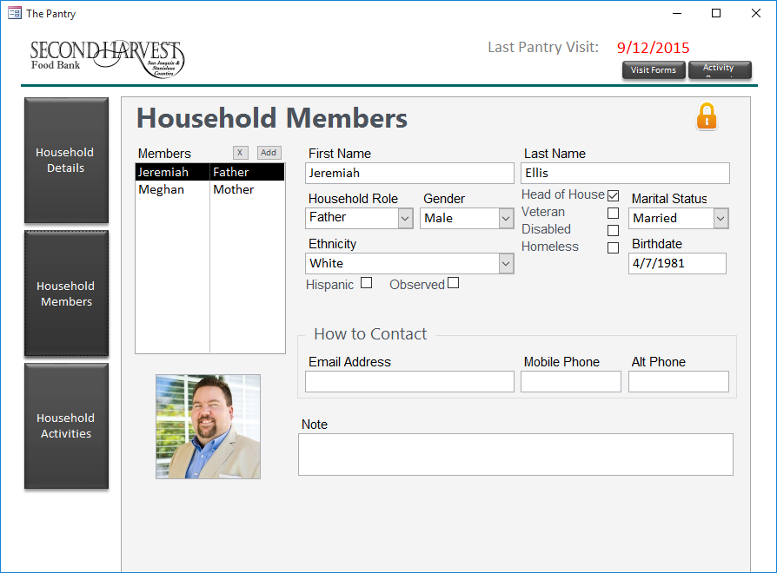

**2**

**1**

1. Navigate through people in the household by clicking on the name in the list
   1. Clicking the [Add] will allow you to add a new member to the household
   2. Clicking the [X] button will allow you to remove members from the household
2. The lock icon here operates the same as the other screens. Unlocked icon means you can edit the information shown for each member.

# Household Activity

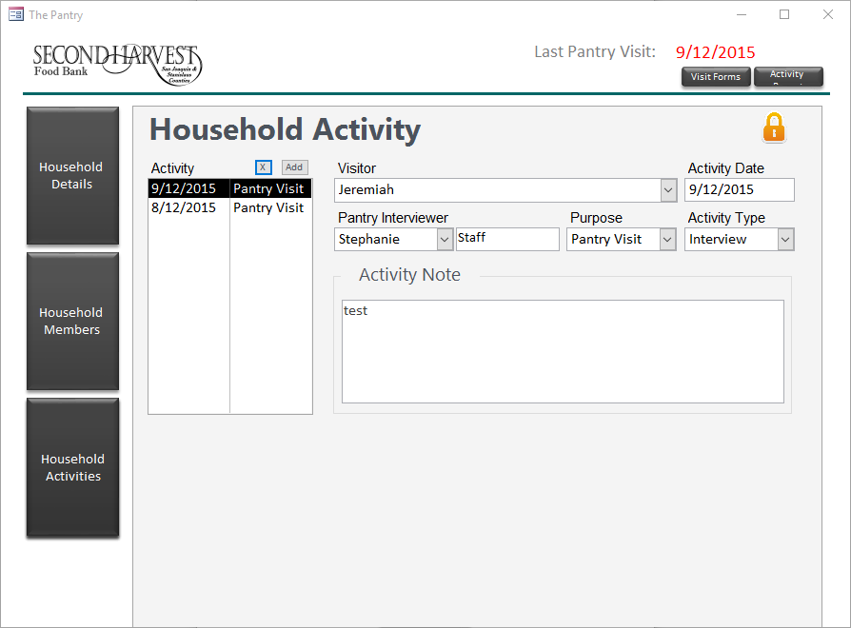

**2**

**1**

1. Navigate through activity dates for the household by clicking on the date in the list
   1. Clicking the [Add] will allow you to add a new activity to the household
   2. Clicking the [X] button will allow you to remove activities from the household
2. The lock icon here operates the same as the other screens. Unlocked icon means you can edit the information shown for each activity.